**Creating a block model (Machine vice Base)**

Creating a block

1. Create new blank workspace using standard mm ipt.

1. Start new 2d sketch.

1. Select X-Y plane.

1. Select 2 point rectangular tool and create rectangle from centre point (type in dimensions) X first(enter dimension value) > TAB >Y second( enter dimension value) > enter.

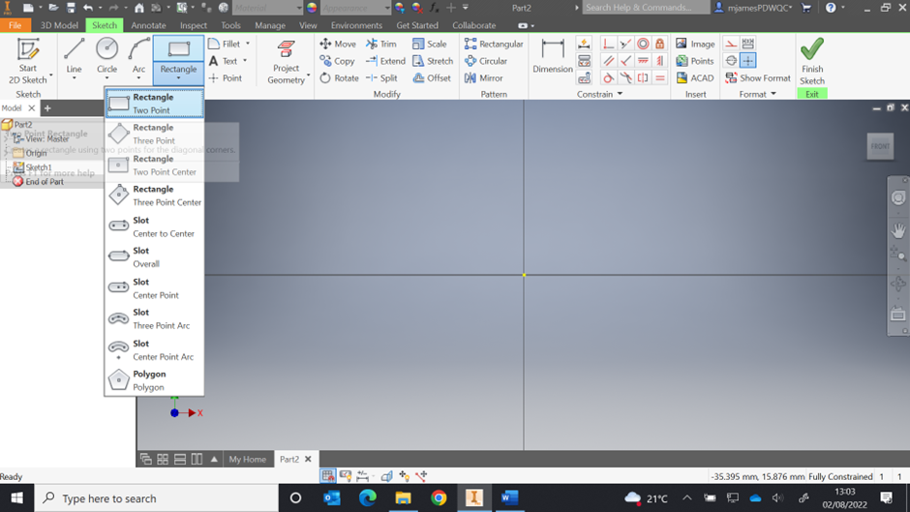

1. Finish sketch.

1. Select extrude tool.

1. Extrude rectangle 10mm in forward direction.

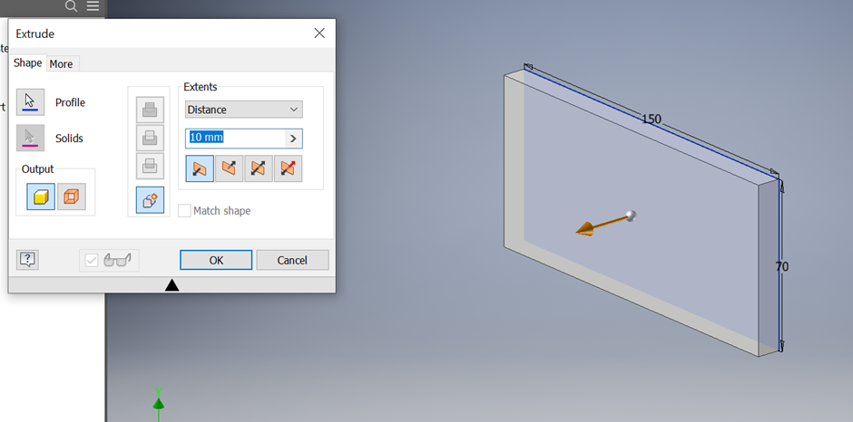

Creating holes in a block

1. Start new 2d sketch on front face of rectangle.

1. Select point tool.

1. Select 2 points on the block, right click, press ok.

1. Select dimension tool.

1. Position points using dimension tool to correct positions as marked on drawing provided for 2 M6 threaded holes.

1. Finish sketch.
2. Select hole tool.

1. Change features on hole tool to:

* Type – Tapped hole.
* Seat – None.
* Threads:
  + Type – ISO metric profile.
  + Size – 6mm.
  + Pitch – M6x1mm
* Size:
  + Termination – Through all.
* Click ok.

1. Create new 2d sketch for matching size holes and repeat above steps with appropriate types and sizes ect.

1. Create new 2d sketch on back side of plate.
2. Place 2 points.
3. Dimension into correct position.Chart, box and whisker chart

   Description automatically generated
4. Select hole tool and change parameters to:

* Type – simple hole.
* Seat – Counterbore.
* Termination through.
* Counterbore dimensions:
  + Head Ø = 10mm
  + Head depth = 5.1mm
  + Hole size = 5.5mm

Creating slot in base and chamfered corners

1. Create 2d sketch on front face.

1. Select rectangle tool and draw rectangular shape inside block, left click to form shape and then right click and press ok.

1. Use dimensions tool to position and size.
2. Finish sketch.
3. Select extrude tool.
4. Select rectangular shape as profile.
5. Select cut away feature and set depth to 4mm.

1. Select chamfer tool.

1. Set distance to 5mm.

1. Select corners to be chamfered.

1. Click apply.

Creating stepped slot

1. Create new 2d sketch on front side of block.
2. Select rectangle tool.
3. Draw required rectangle shape inside block.

1. Dimension and position hole with dimension tool.

1. Finish sketch.
2. Extrude to full depth of block using cut feature.

1. Select 2d sketch on back face.
2. Draw new rectangle as per dimensions around existing cutout and dimension as appropriate.

1. Finish sketch.
2. Extrude hole back using cut feature.

1. Select fillet tool.

1. Set radius to 3mm and select edges to be filleted and click apply.

1. Save file to correct file location under MV001.