**Producing a Block model (Practice 1: Simple cylinder)**

1. Select New from Menu bar.

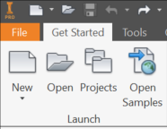

1. Select Folder: Metric.

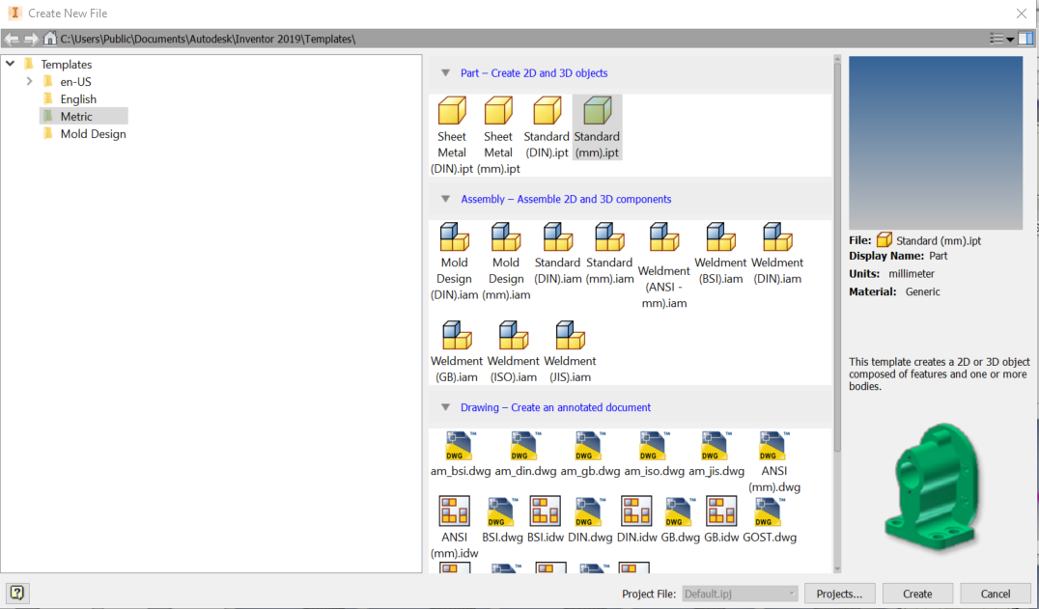

1. Select standard (mm).ipt (inventor 2D part) and click create.



1. If style conflict message appears, click ok.

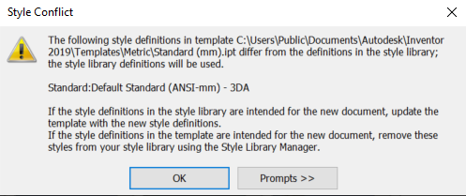

1. Select start 2D sketch.

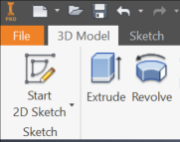

1. Selects XY Plane.

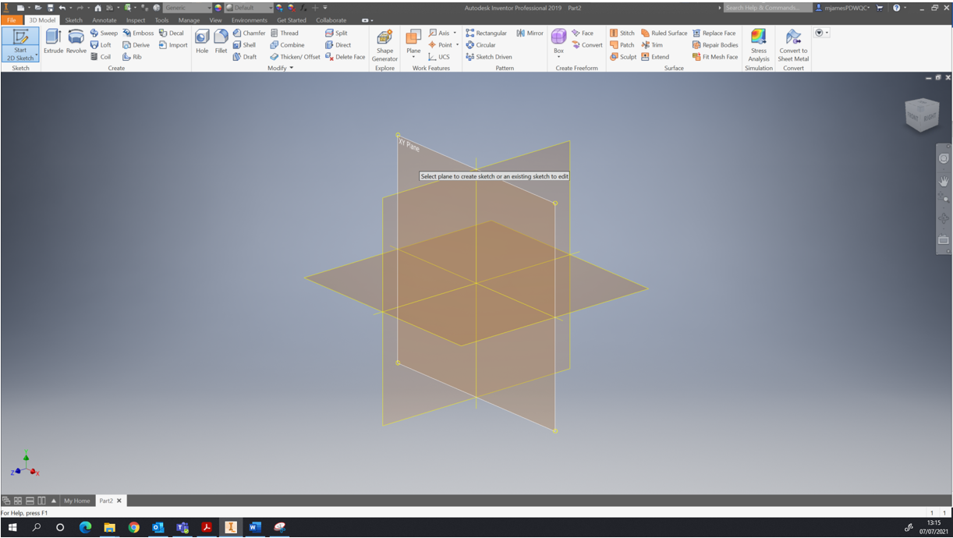

1. Select Circle shape.

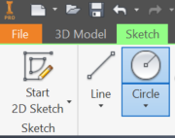

1. Select centre point of circle and right click.

1. Drag circle to required size or enter dimensions in highlighted box.
2. Right click and select OK.

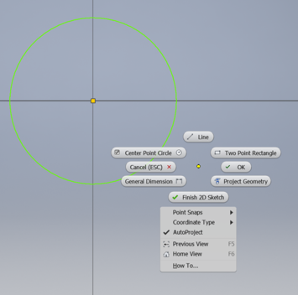

1. Select Finish sketch.



1. Select extrude tool.

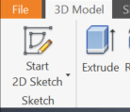

1. Fill in details of dimensions required.

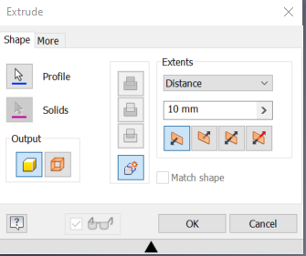

1. Select OK.

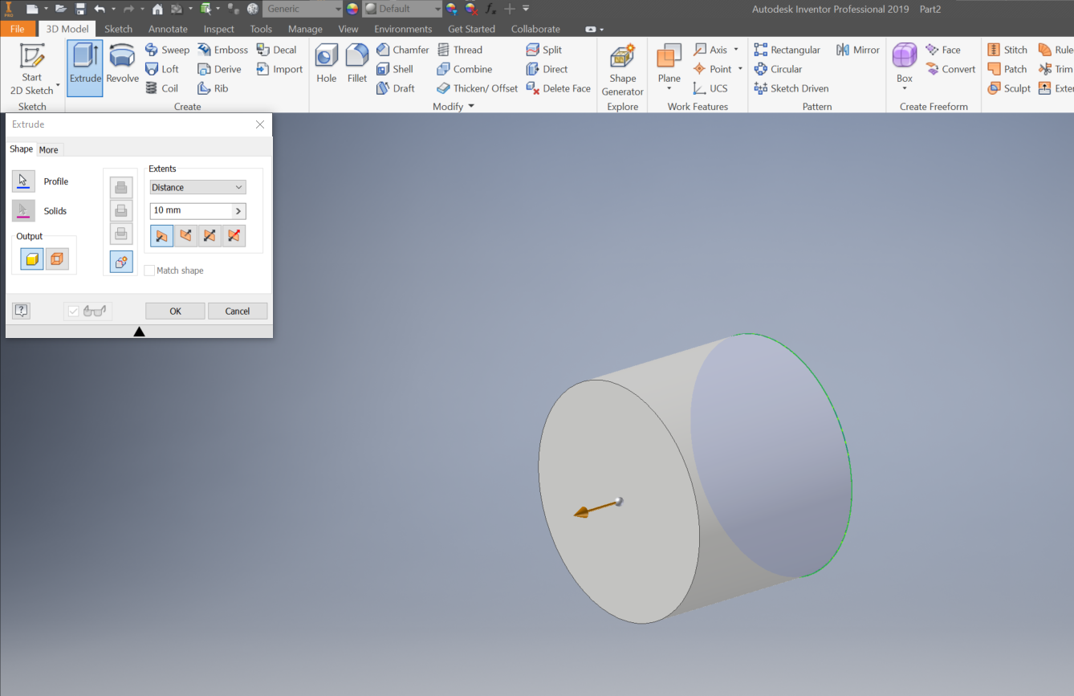

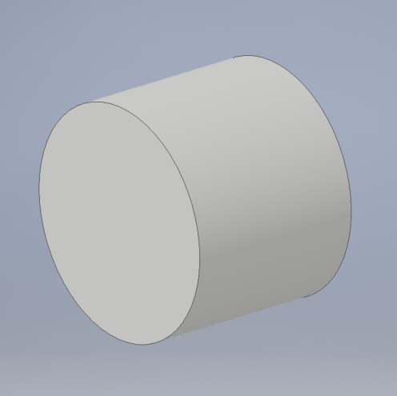

1. Save Model.

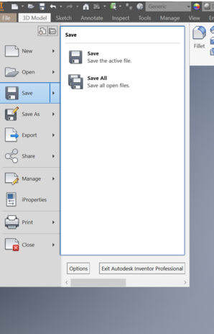

1. Save in appropriate folder as Practice 1.

