VERNIER SCALE: Identification

The vernier is made up from lots of different parts. Look at the picture below.

Indentify each part of the vernier and list them in the table below with corresponding number.

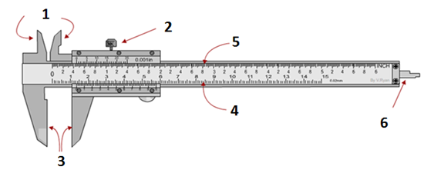

**Number Description Choices**

|  |  |  |
| --- | --- | --- |
| 1 |  | METRIC SCALE |
| 2 |  | DEPTH MEASURING BLADE |
| 3 |  | IMPERIAL SCALE |
| 4 |  | LOCKING SCREW |
| 5 |  | INTERNAL JAWS |
| 6 |  | EXTERNAL JAWS |

**HOW TO READ A MEASUREMENT FROM THE SCALES**

**EXAMPLE 1:** The external measurement (Diameter) of a round section piece of steel is measured using a Vernier Calliper in metric scale

**MATHEMATICAL METHOD**

1. The main scale is read first and this shows that there are 13 whole divisions before the 0 on the hundredths scale. Therefore the first number is 13.
2. The hundredths scale is then read. The best way to do this is to count the number of divisions until you get to the division that lines up the main scale. This is 21 divisions on the hundredths scale.
3. This 21 is multiplied by 0.02 giving 0.42 as the answer (each division on the hundredths scale is equivalent to 0.02mm).
4. The 13 and 0.42 are added together to give the final measurement of 13.42mm (the diameter of the piece of round setion of steel)

COMMONSENSE METHOD

Alternatively, it is just as easy to read the 13 on the main scale and 42 on the hundredths scale. The correct measurement being 13.24mm

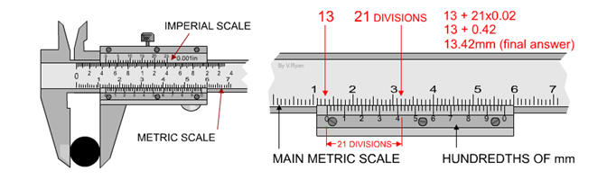

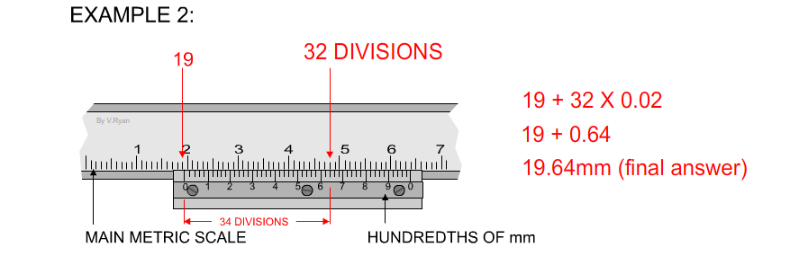

The picture below shows how to use the Vernier Calliper to measure 3 different dimensions that of external, internal and depth.

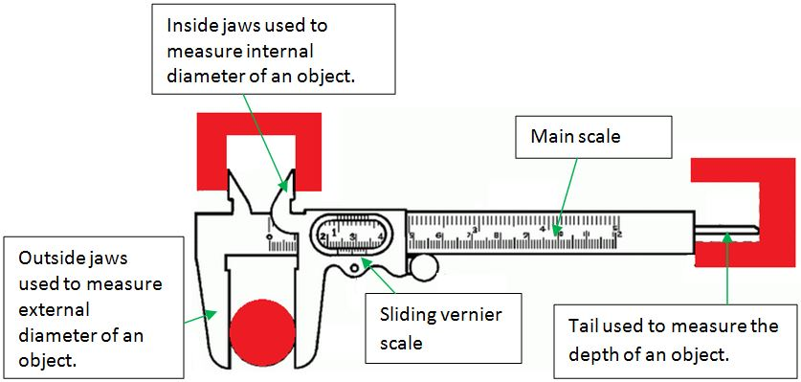

**Variations of Vernier Calliper**

|  |
| --- |
| The Vernier height gauge |

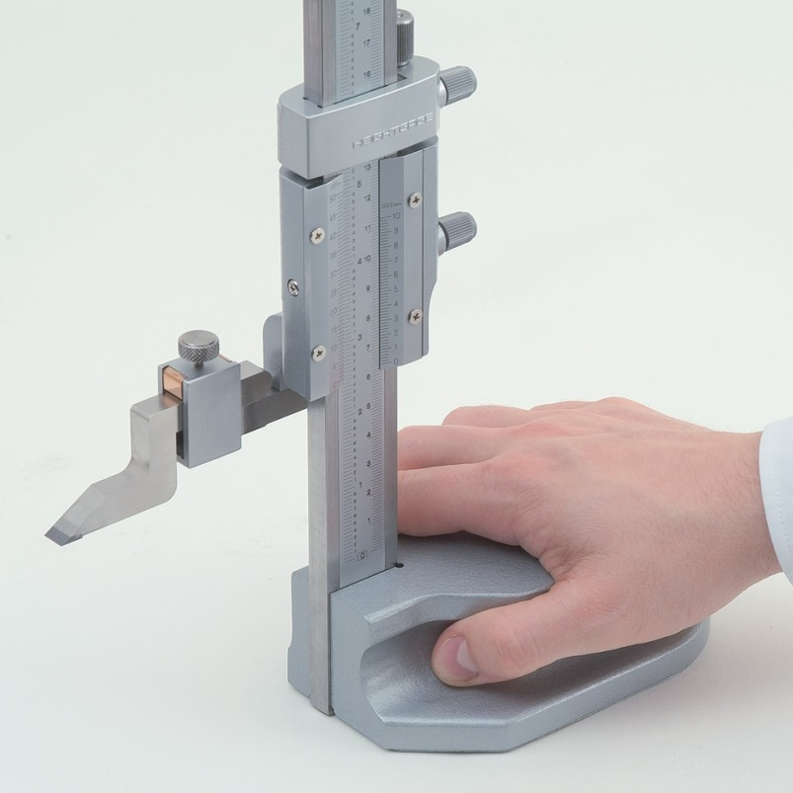

|  |
| --- |
| The Manual Vernier Calliper |

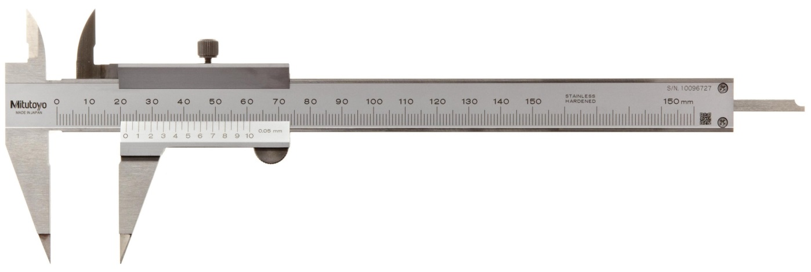

|  |
| --- |
| The Digital Vernier Calliper |

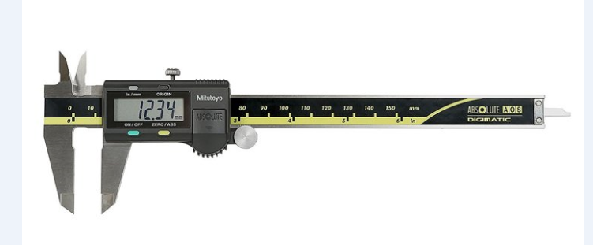

|  |
| --- |
| The Dial Vernier Calliper |

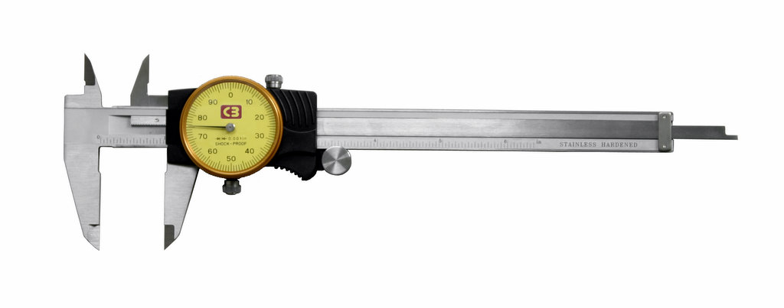

|  |
| --- |
| The Vernier Bevel Protractor |

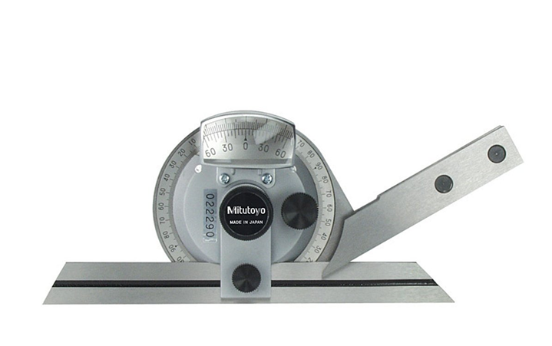

|  |
| --- |
| The Depth Vernier gauge |

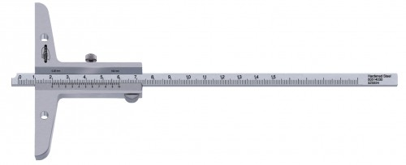

Below are some examples for you to try.

