Exercise 07: Ring and radial Circuits

Name: Date:

Aim

To connect a Ring circuit and Radial circuit, then inspect and test for any faults.

Objective

By the end of this exercise, learners will know the difference between a Ring and a Radial circuit, how to test each circuit as well as rectify any faults found.

Method

1) Safety procedures are in place (risk assessment).

2) Ensure that you have all the required tools and materials.

3) Install the Radial circuit identical to demonstration board.

4) Install the Ring circuit identical to the demonstration board.

5) Complete a visual inspection for defects, then test for non-compliance to BS7671, Schedule of Test Results to be filled out (version B).
Demonstration Board
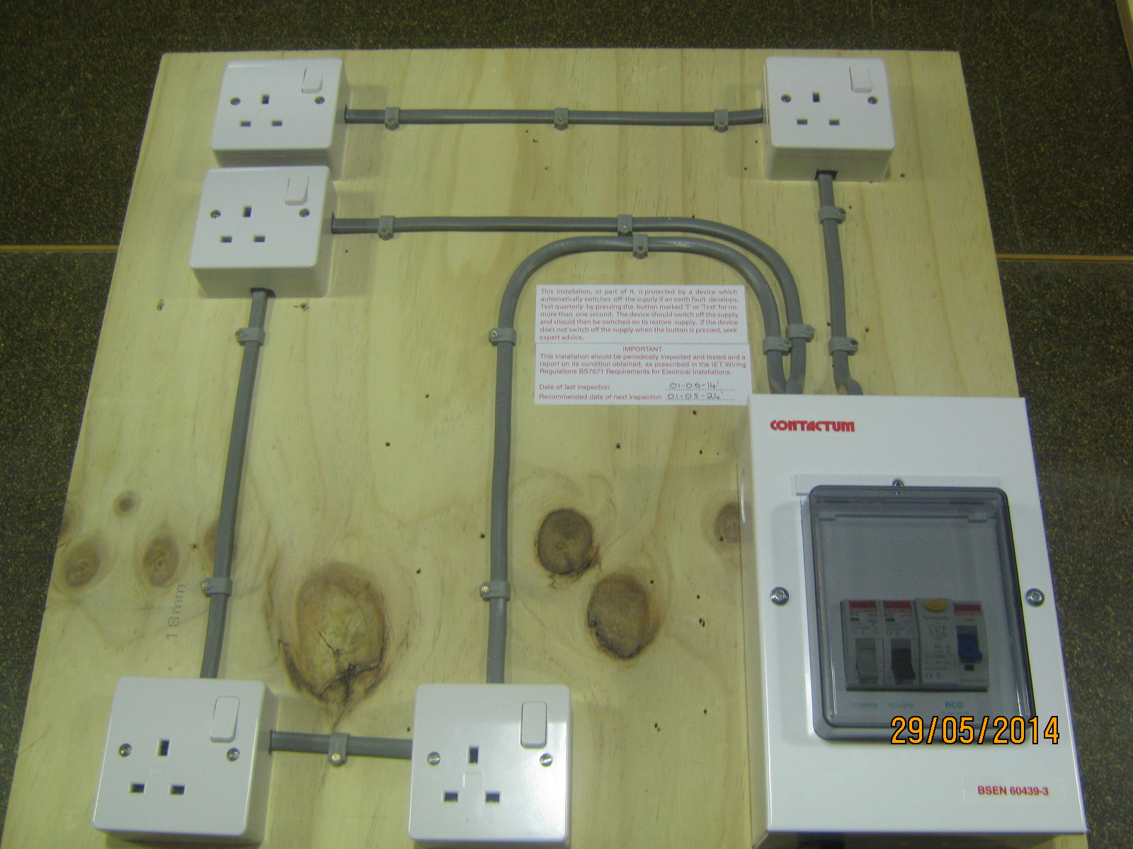

No | Marking Criteria | Pass  √ / X | No | Marking Criteria |  | Pass  √ / X
01 | Risk assessment completed |  | 06 | Visual inspection completed
02 | Tool & Material List completed |  | 07 | Testing completed
03 | Cable & CSA correct |  | 08 | Schedule of Test results filled out
04 | No damage to cable |  | 09 | Fitted as to demonstration board
05 | Minimum exposed conductors |  | 10 | Health & Safety followed
Total

Important: All of the above marking criteria must be met to pass this exercise |  |  |  |  | Marker Signature:

Materials, Tools & Equipment List

Knowledge Question: What fault did you find on the visual inspection and how did you rectify it?

Candidate Feedback (example: How did you feel the exercise went?).
Candidate Signature: | Date:
Instructor Feedback.

Candidate Signature: | Date: | Instructor’s Signature: | Date:

