**Contents**

1. Introduction Page 4
2. Drawing methods Page 5
3. Pictorial drawings Page 6
4. Finger clamp drawing Page 7
5. Orthographic drawings Page 8
6. Exercise Page 11
7. Trigonometry Page 13
8. Dimensions Page 14
9. Lines exercise Page 16
10. Title block exercise Page 17
11. 1st & 3rd angle projection exercises Page 18
12. Drilled and tapped holes Page 20
13. M17 block exercise Page 21
14. Assessed task Page 23
15. **Introduction**

A drawing is a description based on symbols and shapes rather than words.

It should be largely understood by someone who does not even speak the same language as the person who did the drawing.

The purpose of a drawing is to describe an object clearly and accurately. It conveys the details of an idea from one person to another. This will normally be from a designer to the person that is going to make the article.

A drawing is usually the final outcome of a series of discussions and sketches in which the idea was developed. It may have been drawn a considerable distance away from the place where the article is to be produced and there may be no other communication between the designer and the maker.

Therefore it must, together with any associated drawings, contain all the information required to make the article.

The four different styles of drawing experienced in this unit all relate to each other in as much as they supply sufficient information for manufacture or assembly. The choice of which style to use is dependent on how much detail there is on how many faces, and how many views are necessary to convey this information.

**2. Drawing methods**

Clarity is essential in an engineering drawing. The drawing must define;

* The shape of the article by its outlines
* It’s size by stating dimensions

Usually information on material, tolerances and finishes is given. Drawings may also give information in the form of notes.

There are two basic methods of representing an object in a drawing;

* Pictorial
* Orthographic

**Pictorial** drawing gives a quick impression of the appearance of the object. It is mainly used for explanatory drawings. It is not usually suitable for working drawings because of the complexity of most engineered items needs more information that can be provided by a single three-dimensional view. (Fig 2.1)

Fig 2.1

**Orthographic** drawing is the usual method for working drawings. A single orthographic view can only show two dimensions and therefore it is normally necessary to have at least three different views. (Fig 2.2)

In addition there may have to be sections and auxiliary views.

Fig 2.2

1. **Pictorial drawings**

These drawings are produced in two different formats depending on what most appropriately shows the details that are required.

The two formats are:

* Isometric
* Oblique

**Isometric** drawing is a three-dimensional sketch showing both front elevation and side elevation offset by 30° from the base line. All dimensions remain identical to the information given. (Fig 3.1)

30˚

30˚

Fig 3.1

**Oblique** drawing is a three dimensional sketch showing both front elevation and side elevation, the front elevation is parallel to the base line and the side elevation is offset by 45° to the right, the side elevation, otherwise known as the width is drawn half the dimensioned length, all other dimensions remain identical to the information given. (Fig 3.2)

45˚

Fig 3.2

|  |  |  |
| --- | --- | --- |
| TITLE:  FINGER CLAMP | | |
| MAT: HR30 | DIMS: mm | PROJ: OBLIQUE |
| SCALE: 1:1 | TOL: ±0.25 | DATE: 13/09/18 |
| ISSUE: 1 | S/FIN: 1.6µ | SHEET: 1 of 1 |
| DRAWN: MJ | CHECK: | PtNo: 1347 |

A

NOTE:

13mm wide slot to be machined with 6.5 RAD either end centre of 1st hole 31.35 mm from datum

2nd hole 38 mm from centre of first hole

M8 Hole 85.85 mm from datum point

Chamfer 6mm at point A

L

C

20˚

16

48

102

85.85

38

31.35

25

1. **Orthographic drawings**

These drawings are produced in two different formats depending on what most appropriately shows the details that are required.

The two formats are;

* 1st angle projection
* 3rd angle projection

Both of the systems are approved internationally and are regarded as being of equal status. The person producing a drawing can therefore follow principles which, if correctly applied, can be universally understood. The system of projection used on a drawing should be clearly shown, either by using the symbol or some other appropriate means.

Orthographic drawings show at least three views, all drawn to the same scale.

**1st angle projection** drawing; which is European in origin.

The symbol shown (Fig 4.1) is the standard symbol for 1st angle projection. It will always be shown on any drawing that is drawn to either **BS308** or **BS8888**.

It can be recognised by the edge being “hinged” or the cone being slid around the outside of an inverted bowl.

Fig 4.1

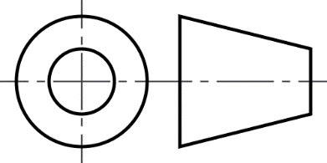

**3rd angle projection** drawing; which is American in origin.

The symbol shown (Fig 4.2) is the standard symbol for 3rd angle projection. It will always be shown on any drawing that is drawn to either **BS308** or **BS8888**.

It can be recognised by the cone being slid around the inside of a bowl.

Fig 4.2

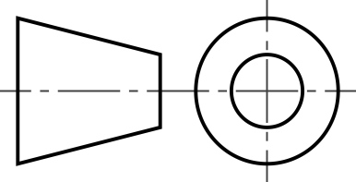

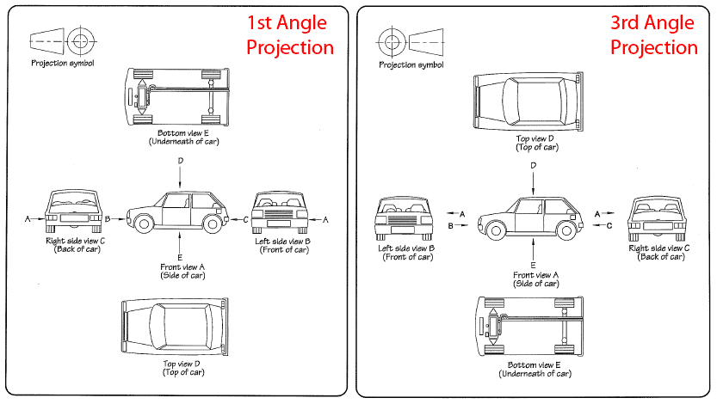

**1st angle projection** drawing; which is European in origin. Fig 4.3

**3rd angle projection** drawing; which is American in origin.

Fig 4.4

The two views (Fig 4.3 and Fig 4.4) show typical layouts for 1st and 3rd angle projection drawings, the construction lines are there for clarity. The 45° line can be any distance along the base line, if it is from the corner of the top left view the gaps between views will be equal, if the angled line is used the top right view will be generated from the other two.

**6. Exercise**

On page 11 there are eight problems that require you to decide whether they are 1st angle projection or 3rd angle projection.

Tick or cross the appropriate box that you believe is correct.

Number eight has an error, can you identify it?

When the task is complete, let your tutor know, they will then check through the answers with you.

|  |  |
| --- | --- |
| First Angle  Third Angle | Third Angle  First Angle |
| Third Angle  First Angle | Third Angle  First Angle |
| First Angle  Third Angle | Third Angle  First Angle |
| First Angle  Third Angle | Third Angle  First Angle |

Third angle

1. **Trigonometry**

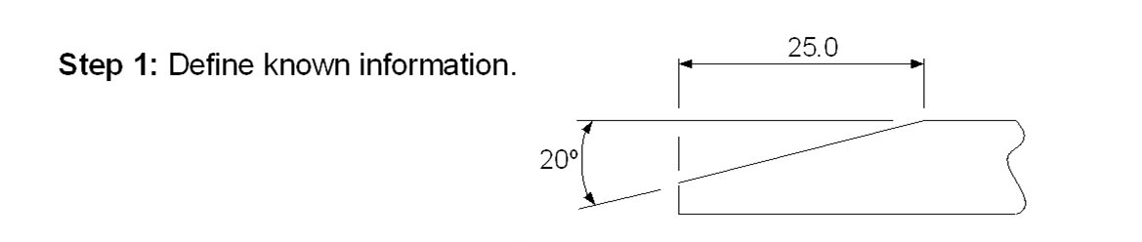

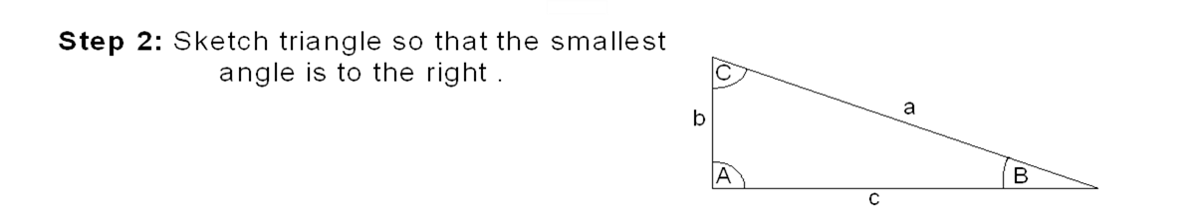

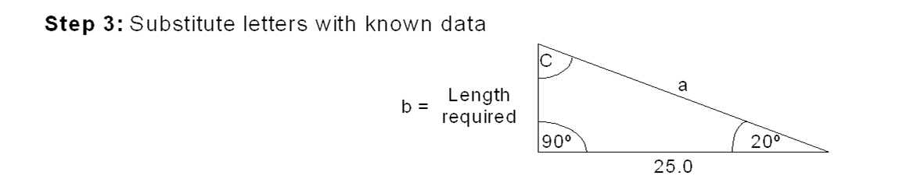

Formula: b = c Tan B

b = 25 Tan 20

b = 9mm

1. **Dimensions**

5 off holes 20Ø thru

Slot 10mm deep

10

100

A

A

50

80

20

20

60

DATUM CORNER

100

210

140

20

SECTION ON ‘A’-‘A’

Dimensioning or machining from a **datum** point will prevent a build-up of tolerances, known as accumulative error.

As shown on the drawing above of a plate overall dimensions 210 x 100 x 20mm, with a slot 10mm wide and 10mm deep at one end cut across the major face. There are also five 20mm diameter holes machined through the plate, centres as defined. The side view, (lower drawing) is shown as a section that is to say that the plate has been cut in half length ways through its centre, 50mm. The section, or cut areas are defined by “**Hatching**”, this is diagonal lines, which cannot be misinterpreted as anything else, drawn across the face. As can be seen in the example, the hole on co-ordinates 140 x 50 is shown as two solid lines without hatching in the middle, this is because this hole has been cut through its own axis and so does not have any cut areas to hatch. Whereas the other two holes, are shown in hidden detail because they are behind the section ‘A’-‘A’ cut line.

The type or style of line used in this drawing is called the **Convention**. The conventions used in the example drawings are as listed below in bold lettering, there are many more, for a full listing of the latest issue see **BS 308 part 1**.

**Continuous thick line** – used to draw visible outlines and edges. (Twice the thickness of a thin line)

**Continuous thin line** – used for dimension lines, projection lines and hatching. (When used for dimensioning the line *must* stop between 1.5 and 2mm away from the component profile)

**Dashed thick lines** – used to show hidden outlines and edges.

(Gaps are half the length of the dashes)

**Thin chain lines** – used to show centre lines, pitch lines and pitch circles. (Long and short dashes, long dashes to be at least twice as long as the short ones, with gaps equal to a short dash).

Notes on drawings done on A3/A4 paper, must be done in capital lettering 3mm high, if there is a need for more than one line of text there must be a 2mm gap between the lines of text.

If a drawing is created 2:1 scale on A3 paper, a border of 10mm must be applied, the text and spaces stay the same.

Title box defined on assessment task sheet.

**9. Lines exercise**

|  |  |
| --- | --- |
| Construction lines |  |
| Contour lines |  |
| Centre lines |  |
| Hidden details lines |  |
| Dimension lines |  |

**10. Title block exercise**

Use a 10mm page border and attach the title box as shown below.

Title box must be placed in the bottom right hand side of the drawing.

Lettering used for the title name is to be 10mm high and all other lettering to be 3mm high.

The image below is NOT drawn to scale.

|  |  |  |
| --- | --- | --- |
| TITLE:  TITLE BOX EXERCISE | | |
| MAT: | DIMS: | PROJ: |
| SCALE: | TOL: | DATE: |
| ISSUE: | S/FIN: | SHEET: |
| DRAWN: | CHECK: | Pt No: |

60

30

40

20

10

35

70

105

|  |  |  |
| --- | --- | --- |
| TITLE:  FINGER CLAMP | | |
| MAT: HR30 | DIMS: mm | PROJ:  1st Angle |
| SCALE: NTS | TOL: ±0.25 | DATE: 13/09/18 |
| ISSUE: 1 | S/FIN: 1.6µ | SHEET: 1 of 1 |
| DRAWN: MJ | CHECK: | PtNo: 1347 |

16

6

45˚

20˚

48

13

25

38

32

86

102

L

C

|  |  |  |
| --- | --- | --- |
| TITLE:  FINGER CLAMP | | |
| MAT: HR30 | DIMS: mm | PROJ:  3rd Angle |
| SCALE: NTS | TOL: ±0.25 | DATE: 13/09/18 |
| ISSUE: 1 | S/FIN: 1.6µ | SHEET: 1 of 1 |
| DRAWN: MJ | CHECK: | PtNo: 1347 |

45˚

20˚

16

6

48

13

25

38

32

86

102

L

C

**12. Drilled and tapped Holes**

**A**

**B**

**C**

**D**

The above drawing shows the conventions for drill and tapped, or threaded holes in hidden detail.

**Hole A** – shows a through drilled hole.

**Hole B** – shows a blind drilled hole, the angle at the end is the angle of the drill point which is 118°, for drawing purposes we use 120°.

**Hole C** – shows a through tapped or threaded hole, note that the outside dotted lines are the diameter of the thread.

**Hole D** – shows a blind tapped or threaded hole, a hole of this type is always defined by depth of full thread, length of outside dotted lines.

**13. M17 block drawing exercise**



|  |  |
| --- | --- |
| **Symbol Abbreviations** | |
| Across Flats | AF |
| Assembly | ASSY |
| Centre Line | CL |
| Countersunk | CSK |
| Cylinder | CYL |
| Diameter | Ø |
| External | EXT |
| Not to Scale | NTS |
| Pitch Circle Diameter | PCD |
| Radius | RAD |
| Surface finish |  |
| Threaded hole | THD |
| Tolerance | TOL |

**14. Assessed task**

**Why are you doing this?**

To show an ability to translate a sketch into a detailed drawing in three views.

**What do you need?**

The use of a drawing board and drawing equipment, appropriate materials to produce a drawing on A3 paper.

**How are you going to start?**

Observe Health & Safety at all times.

**Task – Produce a drawing in three views from a given sketch.**

From the sketch below produce a detailed engineering drawing in 1st or 3rd angle projection.

Create a border and title block around the views, to include the following;

* component description,
* part number,
* material,
* name of learner,
* date,
* chosen angle of projection (1st or 3rd).

Side elevation to be half section (lengthways through the slide on the hole centre line). Include all relevant dimensions and symbols indicating section.

**Slide details**

*Material* – Bright mild steel (BMS)

*All* dimensions in mm

*Note*: Hole penetrates the full depth of the slide.

