Test Procedures for Electrical Installations
(Continuity and Insulation resistance)

© K.Brown 2016

Updated for BS7671:2008 (amendment 3:2015)
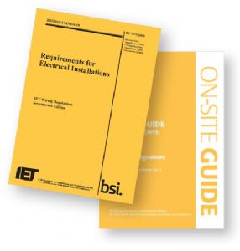

Sequence of Tests (612)

Continuity of protective conductors (including main and supplementary bonding). 612.2.1.

Continuity of Ring Final conductors. 612.2.2

Insulation Resistance tests. 612.3.

Protection by SELV, PELV or electrical separation. 612.4.

Basic Protection by barrier or an enclosure provided during erection. 612.4.5.

Insulation resistance/impedance of floors and walls. 612.5

Polarity. 612.6

Earth electrode resistance. 612.7

Earth loop impedance. 612.9

Prospective fault current. 612.11

Check of Phase sequence (for multiphase systems). 612.12

Functional tests. 612.8, 612.10 and 612.13
- Verification of Volts Drop 612.14
ALL TESTS UP TO AND INCLUDING POLARITY are carried out with the ‘mains’ ISOLATED, Earth electrode resistance (if conducted with a Loop Tester) and subsequent tests are carried out with the ‘mains’ ON. If earth electrode resistance is measured using dedicated tester – this is a ‘dead’ test – so ISOLATE. Functional tests also relate to RCD testing.

Continuity of Earth

There are TWO methods available – (R1+R2) or (R2).

(R1+R2) is often the easier test to carry out for ‘normal circuits’.

(R2) is used for Bonding conductor tests.

POINTS TO NOTE:

Null test leads first – why?

The test instrument will have a voltage supply of between 4 – 24v (ac or dc) and test current of at least 200mA – why?

(R1+R2) test

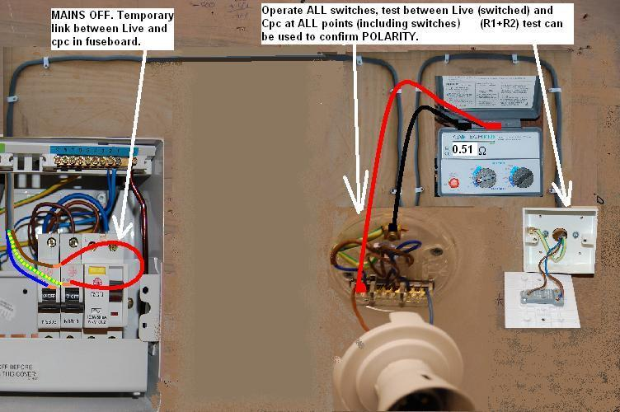
Note: TEMPORARY LINK IN CONSUMER UNIT CAN BE MADE WITHOUT REMOVING THE CONDUCTORS FROM THEIR TERMINALS. They are shown disconnected here for clarity. Simply connect temporary ‘shorting lead’ between circuit breaker ‘busbar rail’ and CPC block. Then turn on MCB for circuit under test. Measure between any switched live and cpc at end of the circuit under test. Repeat for other circuits. REMEMBER to operate switches to PROVE polarity during test.

Continuity of Bonding conductors

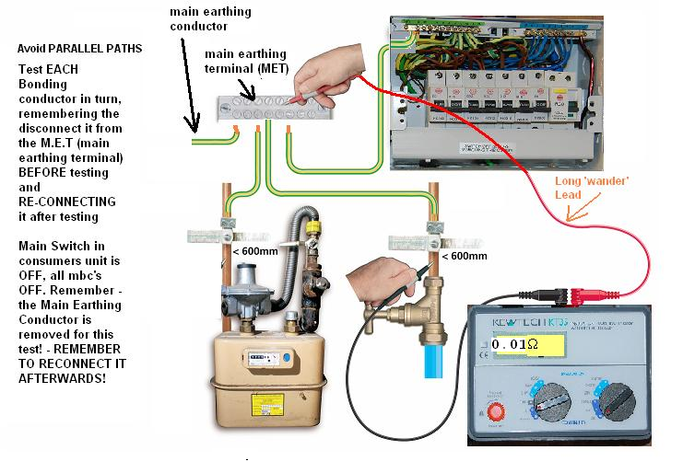
R2 test shown here. REMEMBER to NULL test leads due to relatively low values of BONDING conductor resistance being adversely affected if resistance of test leads was added to final readings inadvertently. Record the measured equipotential bonding conductor reading onto the Schedule of Test Results sheet.

Radial circuit (R1+R2)
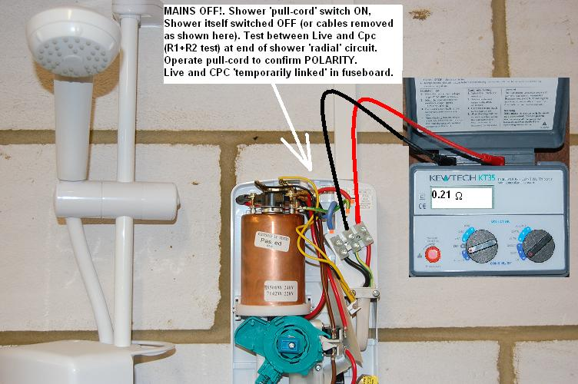

Continuity of Earth (including bonding conductors)

(R1+R2) or (R2) readings will be dependent on LENGTH and CSA of Live and Earth (or just earth) conductor(s) used.

Tables in ‘On-site guide’ give comparative values.

Measured (R1+R2) or (R2) impedance values MUST be LOW ohms readings.

Bonding conductors MUST be 0.05 ohms or less.

These readings are recorded on ‘Schedule of test results form’.

(R1+R2) test can also be used to check POLARITY (so is a preferred test here)

Completing the Test Results Sheet

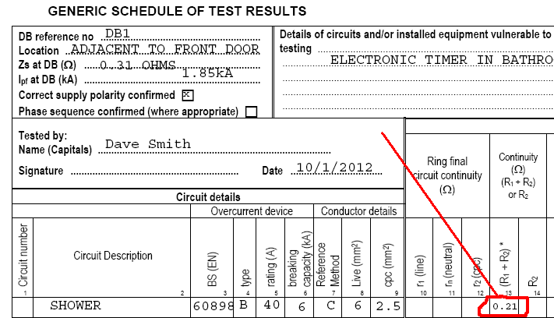

Continuity of Ring Final Conductors

This is the ‘trickiest’ of the ‘dead-tests’ that electricians often find difficult to understand.

The test has TWO purposes.

1) To check that the circuit is in a RING configuration (end-to-end).

2) To check that NO interconnects exist within the ‘RING’ which could give rise to danger.

The tests are carried out in THREE stages….

Continuity of Ring Final Conductors Stage 1 – end-to-end readings.

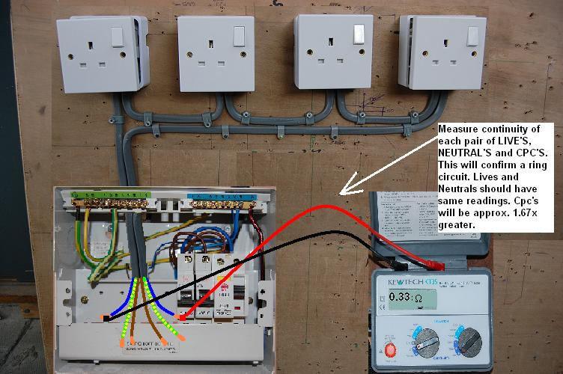
Measure open end live-to-live and make a note of reading, do same for neutrals and cpc’s. These readings are your basis for calculating EXPECTED VALUES for subsequent tests on the RING CIRCUIT.

Continuity of Ring Final Conductors Stage 2 – Phase and Neutral readings.
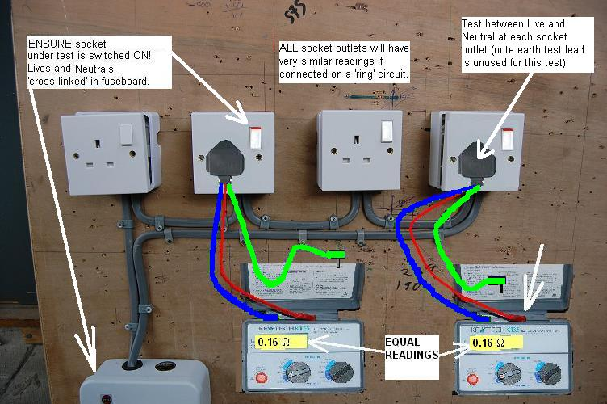
A 1.5 MM SQ CPC WILL HAVE APPROX. 1.67X MORE RESISTANCE THAN A 2.5 MM SQ LIVE CONDUCTOR OF THE SAME LENGTH, hence the cpc-cpc reading being 0.55 ohms (1.67x the 0.33 ohms for the live conductor end-to-end reading).
When ring conductors are cross linked as shown (Live – neutral and Neutral – live cross-linking) TOTAL resistance reading is 0.165 ohms. This is R1 (live end-to-end) + RN (neutral-to-neutral)/4 OR, as both Live and Neutral end-to-end readings were identical, EITHER one divided by 2 (i.e. 0.33/2 = 0.165 ohms). This IS THE EXPECTED READING AT EACH SOCKET OUTLET ON THE RING. A substantially different reading may indicate that ‘that’ outlet is a spur (or interconnect) and should be investigated further. Values from this test are NOT recorded on the Schedule of Test Results – but only used as a reference to each socket.

Continuity of Ring Final Conductors Stage 3 – Phase and Cpc readings.

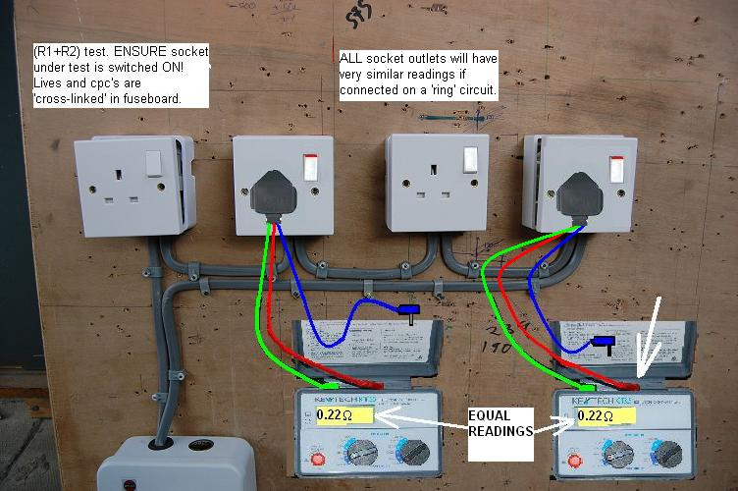
If live-to-live open end readings = 0.33 ohms and cpc-to-cpc open end readings = 0.55 ohms, then when cross linked as shown reading should be 0.22 ohms at position shown and each socket outlet on the ring. This is the EXPECTED READING AT EACH SOCKET OUTLET ON THE RING. A substantially different reading may indicate that ‘that’ outlet is a spur (or interconnect) and should be investigated further.

0.33 (R1) + 0.55(R2)/4 = approx. 0.22 ohms.
R2 value is 0.55/4 = approx. 0.14 ohms.
Record EITHER value onto the Schedule of Test Results.

‘Interconnections’ and ’spurs’ on a Ring circuit

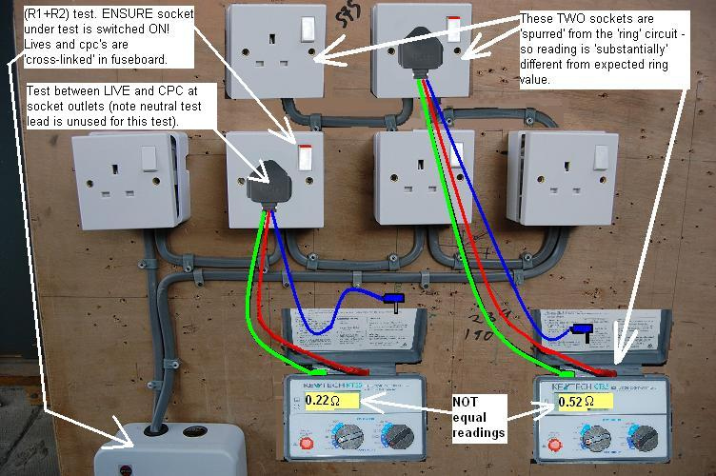
As shown here, a substantially different reading is obtained at an outlet. Here, if the last ‘good’ (i.e. 0.22 ohm reading) socket front were to be removed for closer inspection, THREE 2.5mmsq conductors would be seen. Subsequent sockets with increasing resistance values are the indication of an ‘illegal’ spur.
.

Continuity of Ring Final Conductors RECAP

Measure between EACH end of PHASE, NEUTRAL and CPC conductors (note; phase and neutral should be the same reading, cpc may be slightly higher if its CSA is smaller). Record the results.

Cross-link PHASES and NEUTRALS and measure the resistance at EACH outlet. Total resistance should be (R1+Rn)/4. Check for the same reading at EACH socket outlet on the ring circuit.

Cross-link PHASES and CPC’s and measure the resistance. Total resistance should be (R1+R2)/4. Check for the same reading at EACH socket outlet on the ring circuit.

Any SUBSTANTIALLY different readings and any outlet is an indication of an SPUR or INTERCONNECT at that outlet – investigate further.
RECORD the (R1+R2) measured value onto the Schedule of Test Results sheet.

Adding results to the results schedule

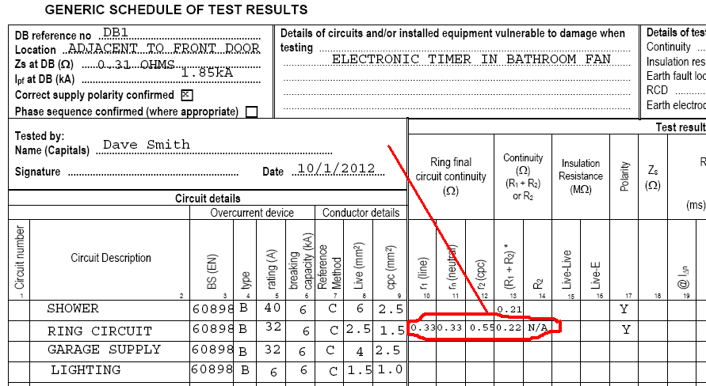

Insulation resistance tests

This is a check on the Insulation quality between LIVE conductors and LIVE conductors and EARTH.

Mains MUST be ISOLATED for this test.

Instruments must generate a DC test voltage.

minimum acceptable INSULATION RESISTANCE is shown on Table 61.

Caution MUST BE EXERCISED when conducting this test – WHY?

Insulation Resistance Test Results

From TABLE 10.3.3 in On-Site Guide

SELV/PELV = 250vDC test voltage, minimum 0.5 M ohms Insulation Resistance
Up to and including 500v (including FELV) = 500vDC test voltage, minimum 1M ohms Insulation Resistance.

Insulation Resistance Test

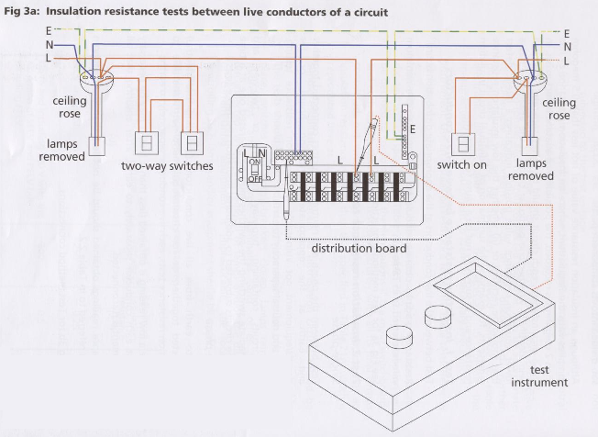

NOTICE – it is NOT necessary to remove ANY of the conductors from their respective terminals during an IR test.
Image from GN3

Insulation Resistance Test

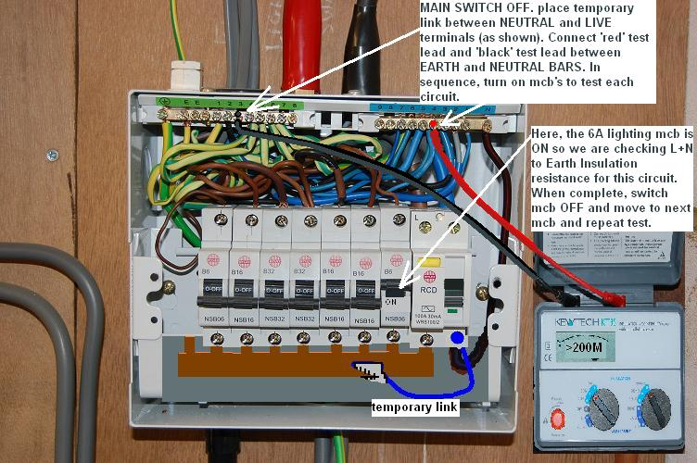
Here live and neutral are linked with a temporary ‘shorting lead’, the test is carried out between LN and earth. MCB for circuit under test is ON. Reading is >1000M ohm so NEITHER Live OR Neutral for this circuit is connected to Earth. This is a PASS as it is above 1M ohm ‘minimum’ acceptable reading (Table 61). A test between L and N will also be conducted.
These tests are then carried out on each circuit supplied by this consumers unit by sequentially switching on the MCB for the circuit under test (after turning OFF others not under test!)

Insulation Resistance Test Results

For 230v and 400v mains circuits, 1M ohm is the ABSOLUTE lowest value of Insulation Resistance that CAN be PASSED – but further investigation must be carried out to identify why the value is so low.

Generally, readings GREATER that 2M ohms can be PASSED without further investigation

To recap, readings between 1M ohms and up to 2M ohms should be investigated further before the readings can be passed.

Recording the results

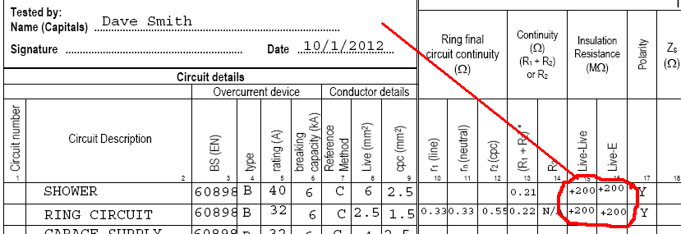

Recap so far…

Continuity readings should be low resistance.

Bonding conductors must be less than 0.05 ohms (max)

Polarity tests can be carried out at the same time and in the same way as (R1+R2) tests.

Ring continuity tests check for (1) the circuit is wired as a ring, and (2) no interconnects or ‘unsafe’ spurs exist in the circuit.

Insulation Resistance tests acceptable results are on TABLE 61. Remember to remove all loads that could affect your readings/or be damaged by the test.

(END)

