Electrotechnical systems – cables and supports

Updated to BS7671:2015

© K.Brown 2016

Cables and cords

‘standard’ cables and cords are PVC (70 degrees C) insulated copper conductors.

This is known as THERMOPLASTIC insulation.

They are used for lighting and power circuits.

Cables are current rated based on their size (CSA).

Their maximum operating temperature MUST NOT be exceeded – factors may have to be applied.

LSF (low smoke and fume) cables are specially designed for ‘special’ installations with increased fire risk.

Single-core PVC insulated cables

These cables are usually ‘unsheathed’.

Available as a SOLID or STRANDED conductor (6491X).

Available in a range of sizes.

Colour codes MUST be adhered to;

Brown = Live (Line)

Blue = Neutral

The ‘Earth’ conductor is BARE and will require green/yellow sleeving to be fitted during termination.

PVC/PVC (flat twin-earth) cables

These cables DO have an outer PVC protective sheath.

Outer sheathing is usually grey or white.

Available in a range of sizes.

Available as SOLID or STRANDED conductor (6242Y)

Two core cable insulation is colour-coded (Brown – Live, Blue – Neutral)
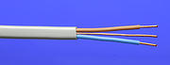

Available with THREE cores and earth (6243Y) for two-way lighting circuits.

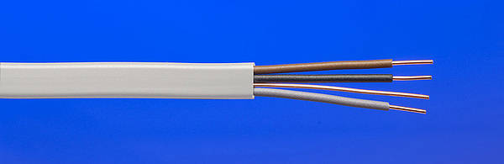

Three-core cables are coloured Brown, Black and Grey (the earth is ‘bare’)

The earth conductor is BARE and will require green/yellow SLEEVING to be fitted when terminating.

Single core PVC insulated and sheathed cables

Usually found connecting the Electricity meter to the consumers unit in domestic dwellings.

Outer PVC sheath offers some extra mechanical protection to the cable.

Inner insulation is colour-coded (Brown or Blue).

Outer sheathing is usually Grey.

Available as Solid or Stranded (6181Y).

Also available with a single, bare copper Earth conductor within the outer sheath (6241Y).

Flexible Cords
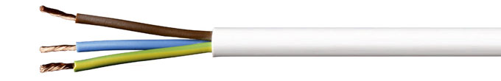

Insulated, stranded, copper cores in an outer circular PVC sheathing up to 4mm².

Maximum load-bearing weight is given in BS7671:2015 ‘on site guide’.

Maximum supported mass (4mm² cord) is 5kg. Support chain is required more mass support.

Available with a number of insulated cores (2,3,4,5)

They have a maximum operating temperature of 85 degrees C.

They are NOT to be used for heating appliances.

Flat twin flexible cord

PVC (60 degree C) insulated and sheathed – but with NO Earth conductor.

Used for TV’s, video and DVD players and other CLASS II equipment.

CLASS II is equipment that has no earthed metalwork so requires no Earth conductor.

They should NOT be used for heating appliances.
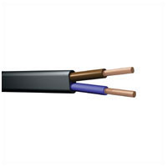 (Oval 2-core flex)

Bell-wire

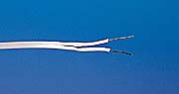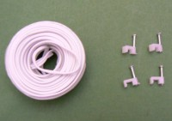

Only to be used on ELV circuits.

ELV = 50v AC or less (120v DC or less).

Simple construction with single soft copper core(s) in a PVC sheathing.

Cores are laid in parallel.

Usually coloured white with a single ‘stripe’ to indicate one core.

SWA (Steel wire armoured) cables

- Robust construction due to steel armoured strands surrounding the cores inside.
- Does not need to be enclosed in conduit/trunking.
- Fixed to surfaces using cable CLEATS or can be secured to cable TRAY systems using cable-ties.
- Requires special GLANDS for terminating into enclosures.
- Used for mains supply cables in arduous environments (factories, outside)
- Available in a range of sizes and number of cores.
- The armour MUST be bonded to Earth.
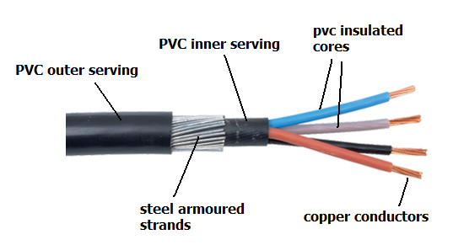

SWA Gland assembly

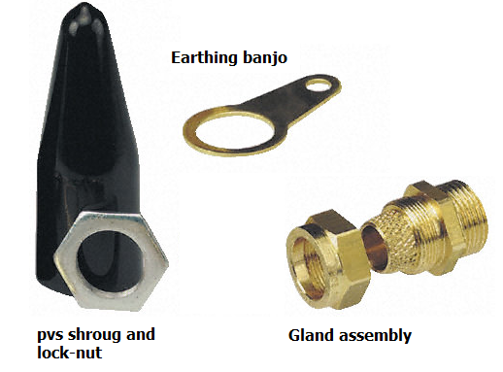

PILC (Paper insulated Lead-clad) cables

- Uses oil-impregnated paper as the insulation around the cores.
- Has a lead cladding around the cable. Lead does not rust and is quite soft so can deform without fracturing.
- Used for underground electrical distribution (mains supply cables).
- Large cables of this type can have oil pumped through special ‘galleries’ in the cable to aid cooling.
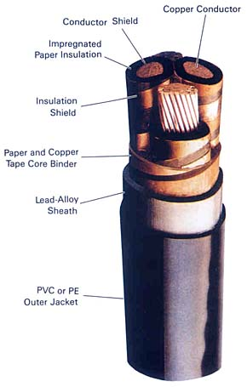

XLPE (Cross-linked Polyethylene) cables

- Similar to SWA and PILC cable construction, these cables have insulation which provides a level of heat-proofing and resistance to chemical attack.
- It is used in warm environments or areas where chemicals may be present in the air (i.e. a boiler room or a paint spray shop)
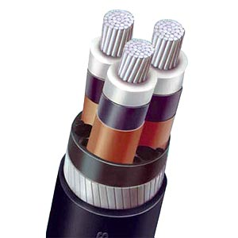

MICC (Mineral insulated Copper clad) cables

- Exceptional resistance to heat and cold. Fire-resistant cable system.
- Also known as MI (mineral insulated), Pyro (Pyrotenax) and BICC (British Industrial Calendar Cable – the original manufacturer).
- Uses Magnesium Oxide (compressed powder form) as the internal insulation around the bare copper cores.
- Requires special tools, glands and seals for termination.
- Un-sealed cables MUST NOT be exposed to moisture/water – or the Magnesium Oxide will absorb it and lose its insulation properties.
- Available with or without a PVC outer serving. Serving is available in a range of colours.
- Used for alarm systems or in areas subjected to extremes of heat and cold.
- Usually installed on a Cable tray system.
- It is very expensive when compared to other cable systems.
- FP Cable (Fire Proof) is a Silicone insulated cable that offers heat resistance at a cheaper price than MI cable.
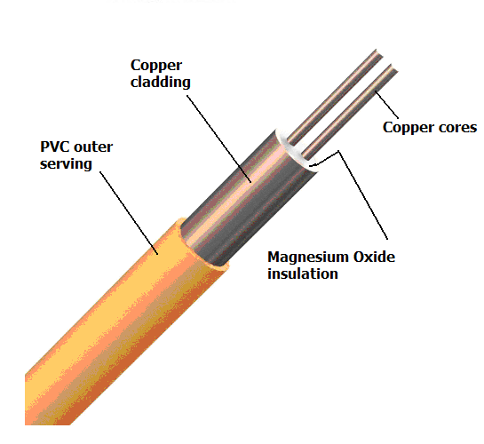

MI terminations
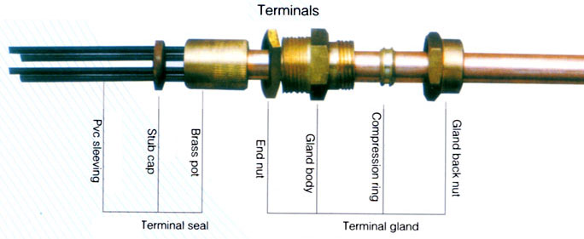

Thermosetting Insulation

PVC can be manufactured to withstand higher operating temperatures.

This process is called Thermosetting.

XLPE cables (Cross Linked Polyethylene) are ‘heat-proof and ‘chemical proof’.

It can operate at 90 degrees C continuously.

Because they can run hotter, they can carry more current for a smaller size OR can carry reduced current in hotter environments.

Fibre Optics systems

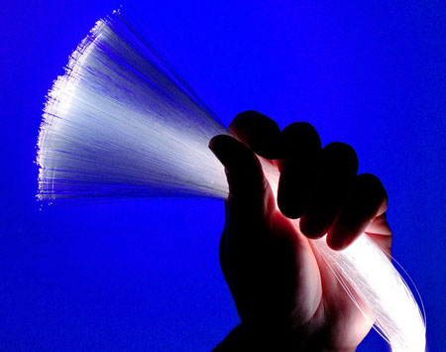

Mostly used in the telecommunication and IT network industries.

Uses ‘laser light’ to transmit data over great distances with only minimal losses.

It is INTRINSICALLY safe – no ‘spark risks’ in hazardous areas.

But there are RISKS!

Fibre Optics systems – precautions

Light source is usually via LASER – so beware of damage to eyes (special glasses shown here).
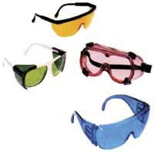

Do NOT bend fibre Optic cable ‘too sharply’ – this will affect its ability to transmit light effectively.
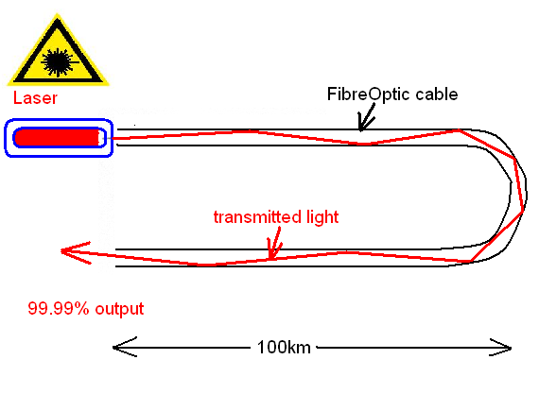

Beware of breaking a fibre Optic cable – sharp shards may cut you!.

Well installed fibre Optic systems can transmit light for many kilometres with virtually NO LOSS in signal strength.

Other data cable system – CAT5

CAT 5 is a ‘standard’ data cable systems found in many IT applications (home pc networks, office IT networks).
- Four pairs of conductors transmit and receive data at high frequency.
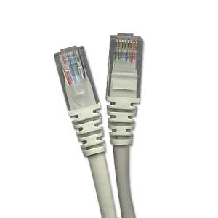

Special tools are required for BOTH Fibre Optic and CAT 5 cable systems.
- CAT 6 is a newer system that can operate in the Giga Bit speed range.

Installing and fixing cable runs

Cable clips (i.e. tower clips) can be used to fix cables to surfaces.

They are made of PVC with a hardened ‘masonry’ nail fitted.

BS7671:2015 ‘on site guide’ gives spacing dimensions for clips (horizontal and vertical).

Different clip designs are available to suit most types of cable and core (flat and round).
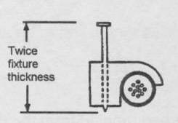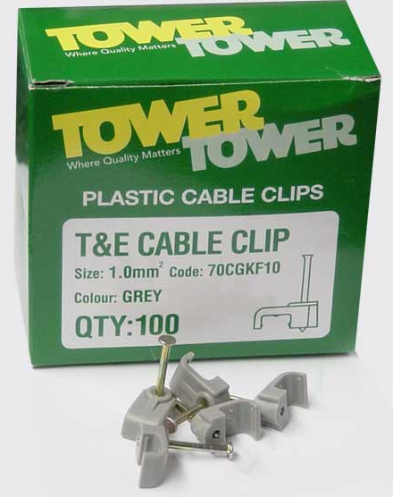

Cable radii should NOT be exceeded (see regulation 522.8.3)

Cable runs and terminations

Cables should be installed level and straight.

Poorly clipped cables can look unprofessional and will not impress the customer.

Protective CAPPING (see pic) should be installed over cables to be buried in cement/plaster. This is because chemicals in the cement/plaster will deteriorate the PVC causing it to FAIL.
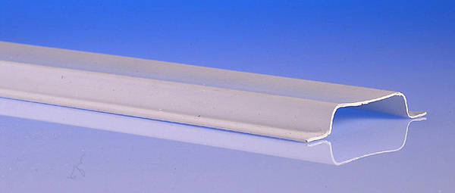 (pvc capping)

Similarly, cables are allowed to be run in CAVITIES within the building structure, HOWEVER, polystyrene cavity wall insulation will be deteriorated by the polystyrene. PVC must NOT come into contact with ANY polystyrene.

Cable runs should NOT run over or near service pipes (water, gas, other) OR unearthed metalwork.

Cable sheathing should be taken into any accessory or enclosure fully. NO conductor coloured insulation MUST be showing OUTSIDE accessories or enclosures.

Cable suspension and Height

Cables can be installed to be suspended in the air. This is known as a CATENARY SYSTEM if the cable is supported by a galvanised steel wire (catenary wire).
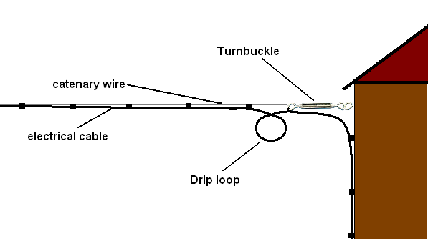

A ‘turnbuckle’ is used to tension the catenary wire.
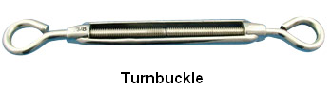
-----------------------------------------------------------------------

A loop is made in the supported cable to allow rainwater to drip off rather than run down the cable and into the wiring system.

Cables MUST be installed to MINIMUM HEIGHT and MAXIMUM SPAN above the floor.

3.5m (no vehicular access)

5.8m (vehicular access)

See BS7671:2015 ‘on site guide’ Table D2 in Appendix D for specific detail.

Fixings – screws

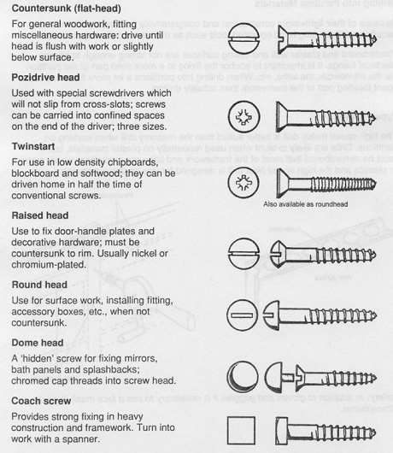

Fixings – Bolts and nuts

Bolts come in a range of sizes.
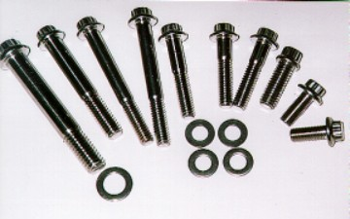

Machine screws are bolts with a thread along its entire length. Used without a nut, they are secured into ‘tapped’ holes.

Bolts and nuts are used for securing parts together through ‘clearance holes’.

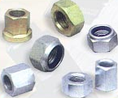 (nuts) 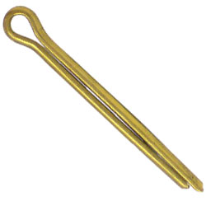 (split pin)

‘Nyloc’ nut (nylon insert)

Castle nut + split pin

A flat washer is used to prevent the nut from marking the surface and provides an interface between nut and surface.

There is a large range of washers available…
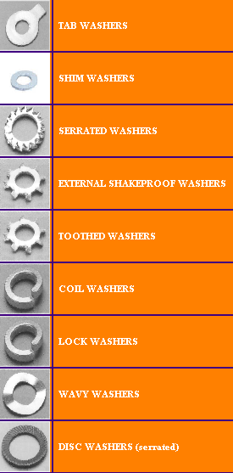

Locking devices

Adhesives (thread lock) can also be used to secure a bolted connection.
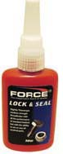

Fixings
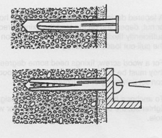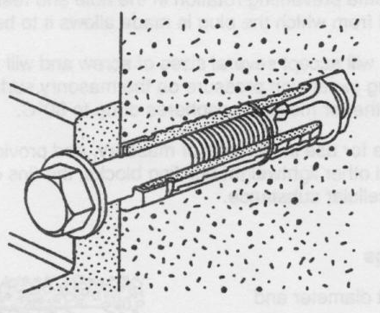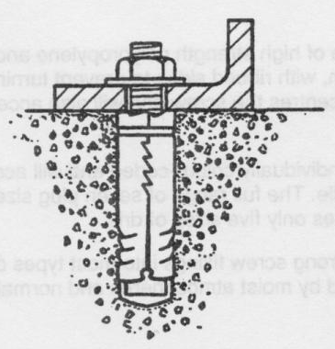

Rawl plugs (pvc and fibre) – for screw fixings into masonry.

Rawl bolts/nuts – bolted expansion fixing into floors/walls.

Also;

Nails – masonry, oval (for wood), panel-pin, roundhead nail (general purpose timber).

Rivets – permanent fixing of thin sheets of steel.

Fixings – cavity walls/ceilings

Spring toggle – for plasterboard and ceiling fixings (with cavity).

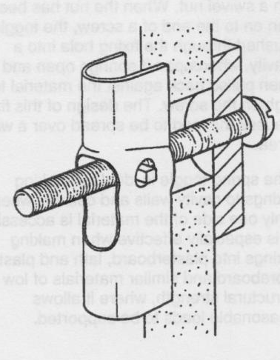

Gravity toggle – for vertical surfaces with cavity (plasterboard wall)
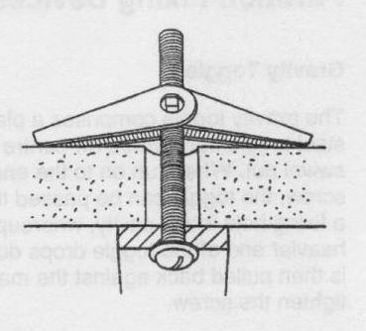

Also - Expansion toggle – for thin surfaces (permanent)

Fixings to structural steelwork

Girder fixings – sprung-steel fixings to steel girders (hammered on).

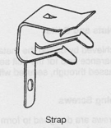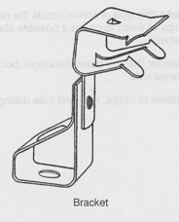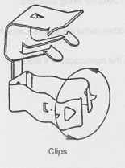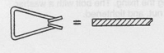

Support systems

Unistrut – bolt-together steelwork for the support, suspension and fixing of electrical systems and equipment.
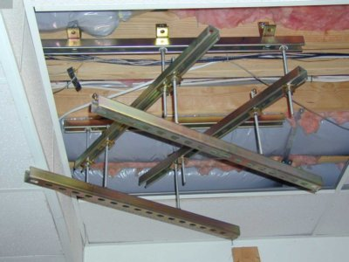

Cable installations in walls

Common method of cable installations in domestic dwellings.

There are ‘safe zones’ where wiring SHOULD be installed (below surface).

Cables SHOULD be installed at least 50mm below the wall surface.

Additional mechanical protection is required if NOT run in safe zones OR less than 50mm below surface.

Additionally, an RCD should be provided for premises without skilled supervision.

See BS7671:2015 regulation 522.6.6, 522.6.7 and 522.6.8 (draw diag below)

Cable installations above ceiling voids and under floorboards

Cables should be secured to floorboard joists or noggins (wooden supports).

Where cables need to pass through joists a 50mm clearance from top of joist to hole AND bottom of joist and hols MUST exist, otherwise mechanical protection is required.

Alternatively, a notch can be cut in joist (but this must NOT weaken the joist – see ‘on site guide’).

See BS7671:2015 regulations 522.6.4 and 522.6.5

Other considerations

Cables passing through holes in metalwork MUST have protective grommet fitted to prevent ‘chaffing’ of the insulation (522.6.1)

PVC insulation is affected by Ultraviolet radiation from direct sunlight. Exposed cables should be protected (522.11.1)

Heat and Fire: cables should be suitably shielded and sealed to prevent excess heat being the source of a fire in the building structure (522.2.1, 527.2.1 and 527.2.4)

